Mining Services Vietnam
Company Profile Structure

Table of Contents

- Company Overview (1 page)
- Leadership & Key Personnel (2 pages)
- Core Capabilities (2 pages)
- Service Delivery Model (1 page)
- Select Projects / Current Work (2 pages)
- Contact Page (1 page)
- Case Study – 500tpd Gold Plant (2 pages) [to be provided later]

Key points to note;

- We are seeking a short and sharp company profile to overview the company and present in the best light. This is not a capability statement, this will be another document that we develop with much more detail including full CVs, equipment etc
- We need Mining Services focused images (not of BPNM) – happy to purchase nice images
- We have a new logo and colour scheme – please use this as the base
- Images required for key management and personnel – same style and position (consistency)

- Company Overview [1 page]

Mining Services Vietnam (MSV) is a Vietnam-based mining services company delivering practical, high-quality solutions to uncover potential and drive progress for our clients across Southeast Asia.

Leveraging our strong local presence, regional experience, and international technical capability, MSV provides cost-effective, practical mining solutions that meet Western technical and safety standards, while remaining aligned with local cost structures and operating conditions.

Our vision is simple:
to deliver high-standard, cost-effective mining services while protecting the environment and ensuring the safety and wellbeing of people and communities.

MSV offers an integrated suite of mining services, including:
- Exploration and geological services, from grassroots exploration through geophysics and drilling, including full program design, execution, and reporting
- Engineering, Procurement and Construction Management (EPCM) services across the project lifecycle
- Resource and reserve development, compliant with local reporting requirements as well as JORC and NI43-101 standards
- Engineering services, including mining, civil, and mechanical disciplines
- Human resources and administrative management, supporting both project and operational teams
- Operational readiness & operations support, helping establish personnel, operating procedures and systems

MSV operates across key mining jurisdictions in Vietnam, Cambodia, Laos, Malaysia, and Thailand, and has experience spanning gold, copper, nickel, antimony, PGE, lead, and zinc.

- Leadership and key personnel [2 pages]

MSV has established a strong local technical and management team, supported by experienced and highly respected mining professionals. The company is guided by an Advisory Board of accomplished industry leaders, providing strategic oversight and independent advice.

In support of the executive management team, MSV has also engaged a group of Senior Technical Advisors who provide JORC and NI 43-101 sign-off capability, along with specialist expertise across environmental, health, safety and sustainability (EHS&S) and geological disciplines, ensuring robust governance, technical assurance, and compliance with international standards.

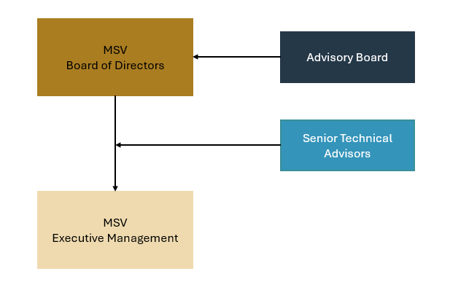

Board of Directors |  | Advisory Board
Lon Taranaki – General Director |  | Dr. Chris Swindells
Hai Nguyen Ngoc – Director |  | Jeremy Ayre
Thanh Nguyen Van – Director

Executive Management Team |  | Senior Technical Advisors
Lon Taranaki |  | Will Coverdale - JORC & NI43-101 Reserves
Hai Nguyen Ngoc |  | Chris Ramsay - JORC & NI43-101 Resources
Thanh Nguyen Van |  | Dr Minh Ding Huu - Geology
Hoan Le Thi Ngoc |  | Hung Tran Huu - EHS & Sustainability
Hung Nguyen Phuc
Tien Dinh Van

 | Bios
 | Lon Taranaki - General Director  Process Engineer with over 31 years’ mining experience across multiple jurisdictions. Strong background in executive leadership, engineering, mining operations, and project delivery, with a Southeast Asia focus across coal, nickel, gold, and copper.
 | Thanh Nguyen Van – Director & Mining Lead  Mining Engineer with 13 years of hands-on experience across open pit and underground operations in Vietnam, Laos, and Cambodia. Strong technical capability supported by proficiency across industry-standard mining software and extensive experience in permitting and licensing mining projects in Vietnam.
 | Hai Nguyen Ngoc – Director & Geology Lead  Geologist with a Master of Science in Geology and over 20 years’ experience across exploration and mine geology management. Strong technical capability with proficiency in industry-standard geological software, extensive experience designing and managing EM, DHEM, and 3D IP programs, and a deep understanding of Vietnamese reserve reporting requirements and JORC standards.
 | Jeremy Ayre – Advisory Board  Mining, consulting, investment, and entrepreneurial professional with over 35 years’ experience. Founder of AWR Lloyd, a boutique advisory firm servicing the mining sector, and an entrepreneur with a track record of founding investment funds and a renewable energy business.
 | Dr. Chris Swindells – Advisory Board  Senior engineering and environmental professional with over 45 years’ experience leading technical teams across the mining and infrastructure sectors. Former senior executive at Golder Associates, where he held multiple leadership roles across Australia, Asia and Africa for over 32 years, including leading the Mining Services team in EMEA and APAC and globally.
Will Coverdale – Senior Technical Advisor JORC & NI43-101 Reserves

Qualified Mining Engineer with an MBA and over 19 years’ experience across the mining and metals sector, spanning open pit and underground operations. Extensive background in project evaluation, due diligence, M&A, project planning and development, technical and strategic consulting, and founder of a mining-related IT start-up. Recognised Competent Person for JORC & NI43-101 Reserve reporting.

 | Chris Ramsay – Senior Technical Advisor JORC & NI43-101 Resources  Experienced mineral resource and mine development professional with over 25 years’ global experience across the mining value chain. Expertise includes mineral exploration, resource estimation, project development and evaluation, resource governance, mine geology, and operational management. Recognised Competent Person for JORC and NI43-101 resource reporting.
 | PhD. Minh Dinh Huu – Senior Technical Advisor Geology  Senior exploration and project evaluation professional with over 40 years’ experience across a broad range of commodities, including nickel–copper (PGE), gold, copper–gold, copper, tin, and mineral sands. Extensive experience in technical review, peer evaluation, and academic supervision, including guidance of undergraduate and MSc theses and service as an examining and review board member for PhD and Master’s research in gold and non-ferrous mineral systems.
 | Hung Tran Huu – Senior Technical Advisor EHS & Sustainability  Experienced EHS & Sustainability professional with 15 years’ experience in electronics, electric vehicle, industrial real estate, metal mining & processing sectors. Highly proficient in international environmental and social (E&S) standards, including IFC Performance Standards, OECD guidance, ISO standards, as well as North American, European, and Vietnamese regulations.
 | Hoan Le Thi Ngoc – Executive Management & HR Lead  Human Resources professional with a master’s degree in human resources management, providing comprehensive HR services to Vietnamese and international organisations. Extensive experience in organisational design, role and job description development, recruitment and onboarding, development of company-wide HR policies and procedures, and holding senior leadership roles.
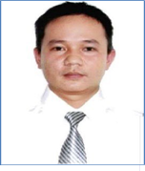 | Hung Nguyen Phuc – Executive Management & Snr Project Manager  Mechanical Engineer with a Bachelor of Science in Mechanical Engineering and experience across engineering and process operations. Strong capability working to international standards including ASME and ASTM. Experience in project management, studies delivery, permitting and licensing approvals, and subcontractor management. Brings deep operational experience having worked as a senior maintenance leader at a world-class tungsten operation.
 | Tien Dinh Van – Executive Management & Snr Project Manager  Construction and civil works professional with a Master’s degree in Transport Works Engineering and a strong background in infrastructure, transport, and civil design. Extensive experience in project and contract management, including delivery of multi-million-dollar construction contracts under FIDIC forms, management of consultants across Pre-FS, FS, detailed and construction design phases, and oversight of contractors and subcontractors during construction execution.

- Core Competencies [2 Pages]

MSV delivers integrated mining services across the full project lifecycle, from early-stage exploration through project development and into operations. Our capability is built on hands-on regional experience, enabling the delivery of technically robust, cost-effective, and operationally practical solutions aligned with project objectives and local operating conditions.

MSV’s core competencies include:

- Exploration & Geological Services
- Resource & Reserve Development
- Project Delivery (Owner’s Team & EPCM)
- Operational Readiness & Support

Exploration & Geological Services

MSV provides an end-to-end exploration capability, combining program design, execution, and technical reporting using in-house teams, equipment, and specialist support delivering improved data quality, schedule control, and cost efficiency.

Key services include:
- Grassroots exploration, including geological mapping, soil and rock-chip sampling, trenching, and technical reporting
- Geophysical surveys, (EM, IP, and DHEM) including design, execution, interpretation and reporting
- Drilling services, from target generation to execution, with over 150,000 metres of diamond drilling delivered
- In-house logging, sampling, laboratory management, and data preparation to support geological modelling and reporting
- Geological database management and technical reporting

Resource & Reserve Development

MSV develops geological, resource, and reserve models using industry-standard software including Surpac and Micromine, compliant with local, JORC, and NI 43-101 reporting requirements.

Reserve development includes mine optimisation and reserve conversion studies, supported by an extensive internal cost database, with certification provided by MSV’s Competent Persons where required.

Project Delivery

MSV operates as Owner’s Representative or EPCM contractor, managing engineering, procurement, construction, and commissioning to achieve scope, cost, schedule, quality, safety, and performance objectives.

Operational Readiness & Support

MSV supports the transition from development to steady-state operations, establishing robust, compliant operating organisations, including HR, procurement, finance, governance, HSE, and reporting systems.

- Service Delivery Model [1 page]

MSV offers a flexible service delivery model aligned to project stage, risk profile, and client objectives, engaging as an advisor, EPCM contractor, or embedded team.

Engagement Options
- Advisory – technical and commercial advice, reviews, studies, and owner’s team support
- EPCM – integrated delivery of engineering, procurement, construction management, and commissioning
- Embedded Teams – MSV personnel embedded within client teams for targeted capability and continuity

Phase-Based Support
- Exploration – program design, execution, and reporting
- Studies & Development – resource, reserve, mine planning, project definition
- Execution – EPCM delivery and owner’s team representation
- Operations – operational readiness, ramp-up, and optimisation

Commercial Structures

- Fee-for-Service - MSV’s primary engagement model
- Equity Participation - selectively considered for the right projects where long-term alignment and material value contribution exist

Across all engagement models, MSV delivers practical, cost-effective solutions to international standards, aligned with local operating conditions and project objectives.
- Select Projects / Current Projects [2 pages]

[to include photos, each project we have a simple check box system as to what MSV is doing (core competencies, delivery model etc.) – need to list all out all competencies and delivery models]

Project 1

Client | Sambo Cambodia
Country | Cambodia
Description | Providing the client with a full suite of services to take their project from exploration through to production.
Commodity | Gold
Status | Aug 2025 - ongoing

Services |  |  | Delivery Model
Exploration & Geological Services | X |  | Advisory | X
Resource & Reserve Development | X |  | EPCM | X
Project Delivery (Owner’s Team & EPCM) | X |  | Embedded Teams
Operational Readiness & Support | X

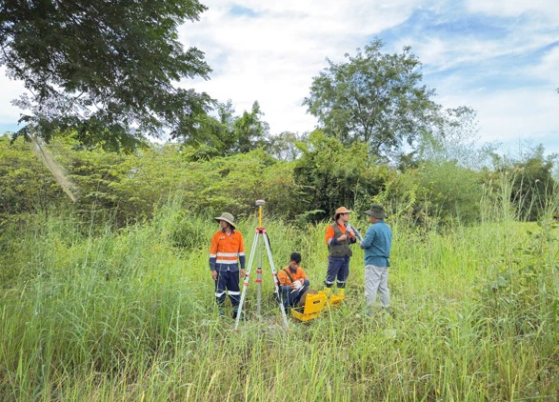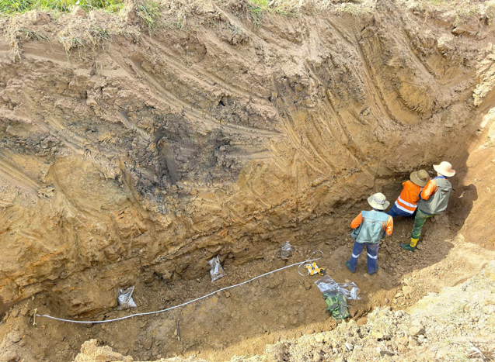

Project 2

Client | Cavico Laos
Country | Laos
Description | Providing the client with grass roots exploration services (mapping, soils, rock chips and trenching) and drill target generation for gold
Commodity | Gold
Status | Aug 2024 – Aug 2025

Services |  |  | Delivery Model
Exploration & Geological Services | X |  | Advisory | X
Resource & Reserve Development |  |  | EPCM
Project Delivery (Owner’s Team & EPCM) |  |  | Embedded Teams
Operational Readiness & Support

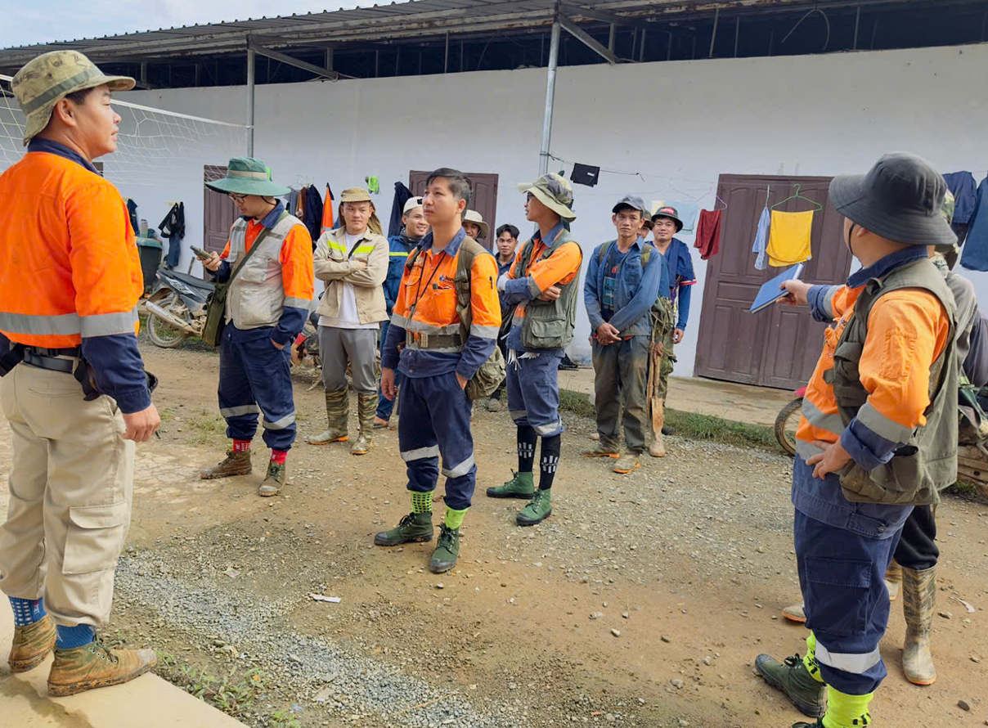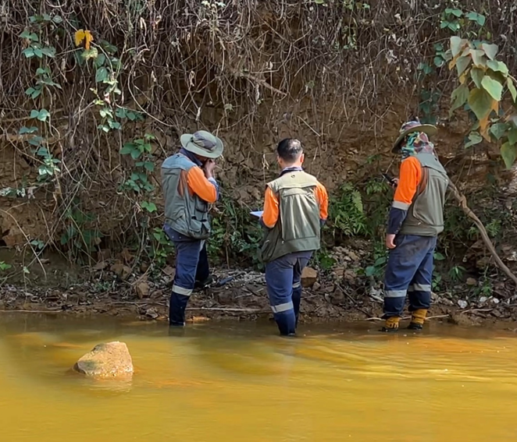

Project 3

Client | Xuan Loc Tho – Ta Khoa Project Joint Venture
Country | Vietnam
Description | MSV has 3 engineers embedded in the clients team to help advance permitting, licensing and project studies (including feasibility study & EIA)
Commodity | Nickel
Status | Aug 2025 – ongoing

Services |  |  | Delivery Model
Exploration & Geological Services |  |  | Advisory
Resource & Reserve Development |  |  | EPCM
Project Delivery (Owner’s Team & EPCM) | X |  | Embedded Teams | X
Operational Readiness & Support

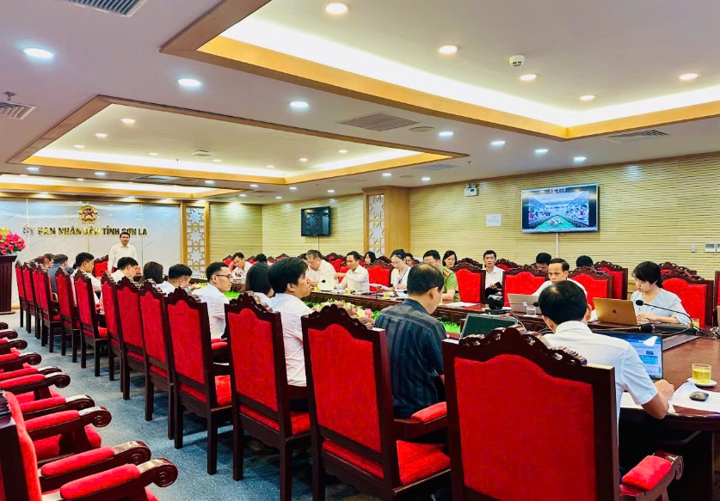

Project 4

Client | ROPA SEA
Country | Vietnam
Description | Engaged to generate M&A opportunities and secure new exploration ground for Antinomy projects in Vietnam. MSV is managing a corporate entity for the client in Vietnam.
Commodity | Antinomy
Status | Aug 2025 – ongoing

Services |  |  | Delivery Model
Exploration & Geological Services | X |  | Advisory
Resource & Reserve Development |  |  | EPCM
Project Delivery (Owner’s Team & EPCM) | X |  | Embedded Teams | X
Operational Readiness & Support

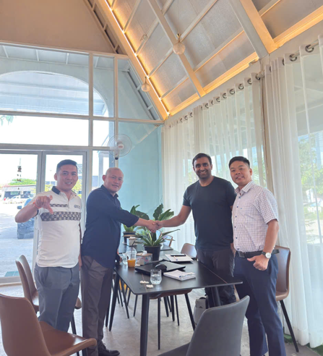

- Contact Page

Company Email:
info@dma-msv.com

Phone:
[xxxxxxxxx]

Contact Persons:
Lon Taranaki Lon@dma-msv.com
Thanh Nguyen Van Thanh.nguyen@dma-msv.com
Hai Nguyen Ngoc Hai.nguyen@dma-msv.com
Hoan Le Thi Ngoc Hoan.le@dma-msv.com
Hung Nguyen Phuc Hung.nguyen@dma-msv.com
Tien Dinh Van Tien.dinh@dma-msv.com

Address
CÔNG TY CỔ PHẦN DỊCH VỤ MỎ VIỆT NAM MINING SERVICES VIETNAM JSC
Văn phòng 5A, tầng 23, tháp A, tòa nhà văn phòng Hudtower, 37 Lê Văn Lương, P. Thanh Xuân, TP. Hà Nội
MST: 0111214046

Website
www.dma-msv.com

Photo Gallery

